1. 
2. 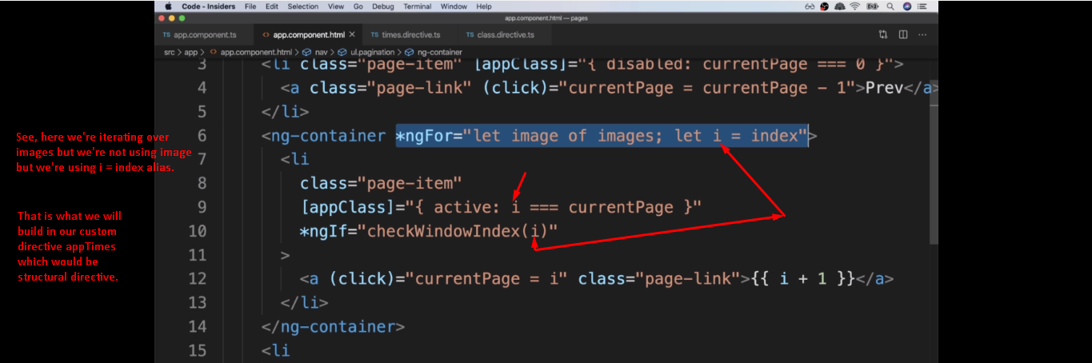
3. 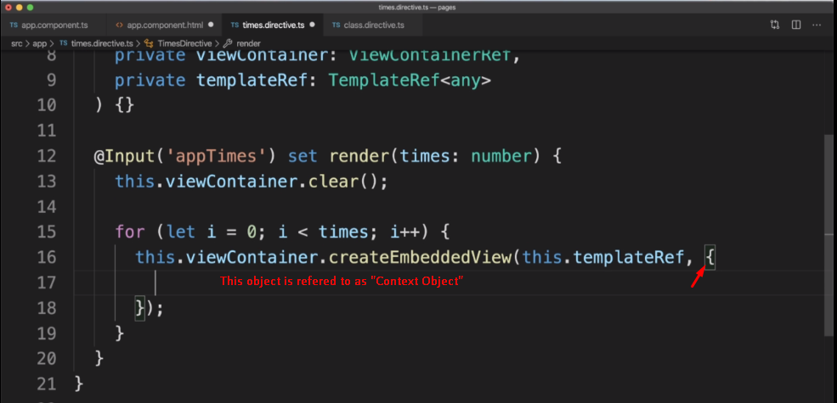  
   **Context Object**:
   1. The key, value pairs provided in the context object are accessible inside our template through our directive.
   2. All the properties on context object available for aliasing inside of our directive.  
      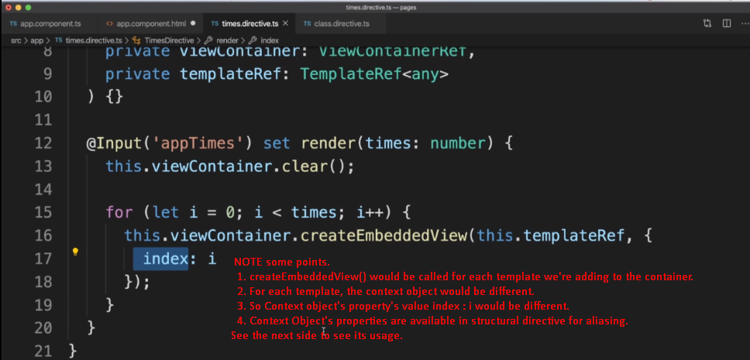
   3. 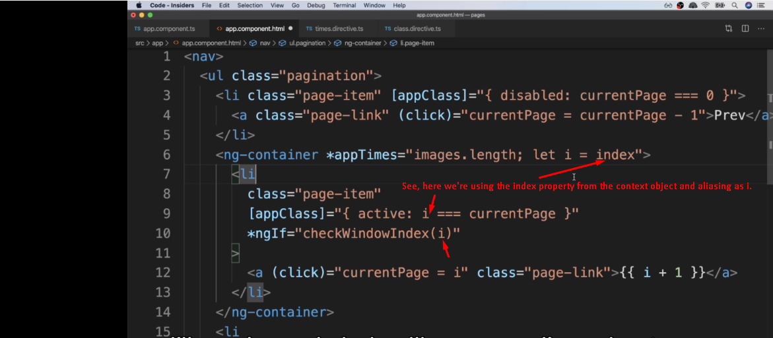
4. 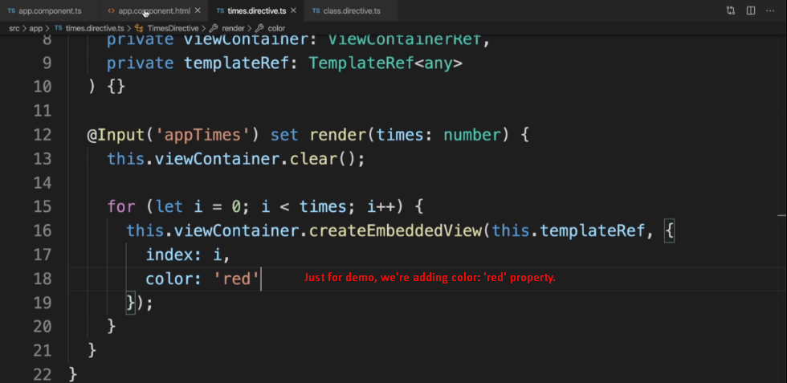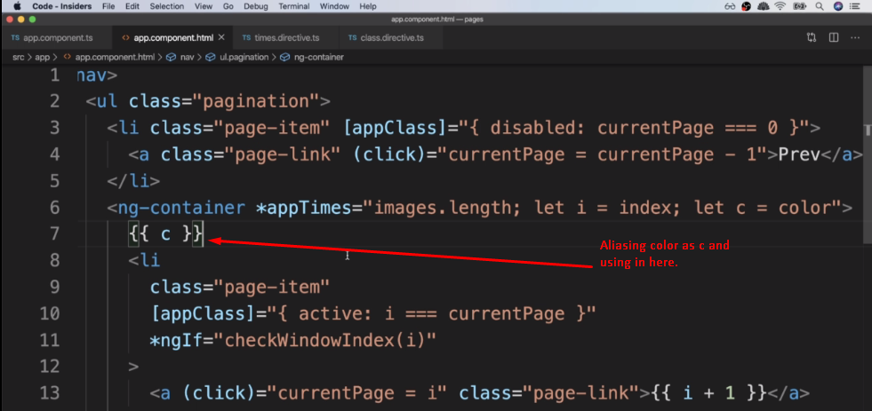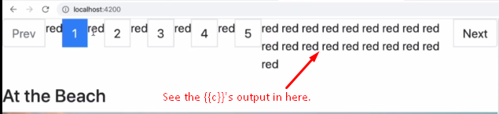
5. **NOTE**:
   1. You’re going attribute directive more often than the structural directive.
   2. Structural directive and Component are so much similar that most of the times, it’s so easy to use the component usually that ends up being a little bit easier and a little bit more clear to other engineer as well.